BELOW CHANGES ARE TO BE DONE AFTER UPLOADING THE TRADE FILE AND POSITION FILE OF 06/10/2016
Corporate action of GRASIM on 06/10/2016
Trading-NSE_FNO-Masters-Corporate Action
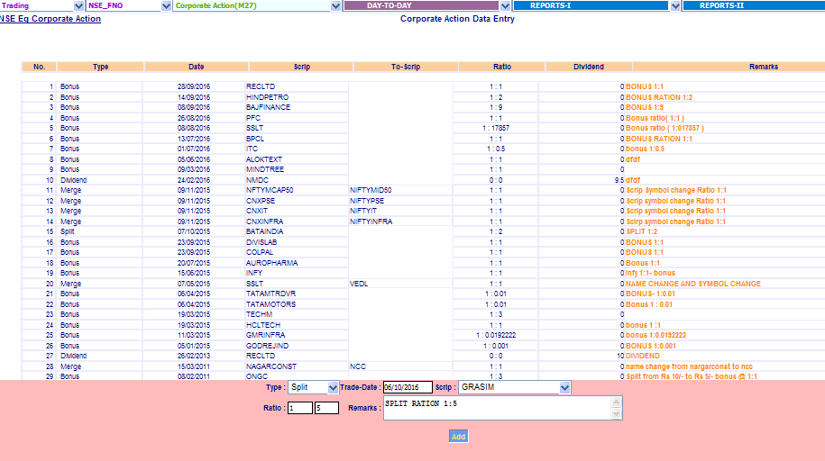
Input type select- Split trade date-06/10/2016, scrip- GRASIM, ratio input (1:5) & Add
After update will display below screen.
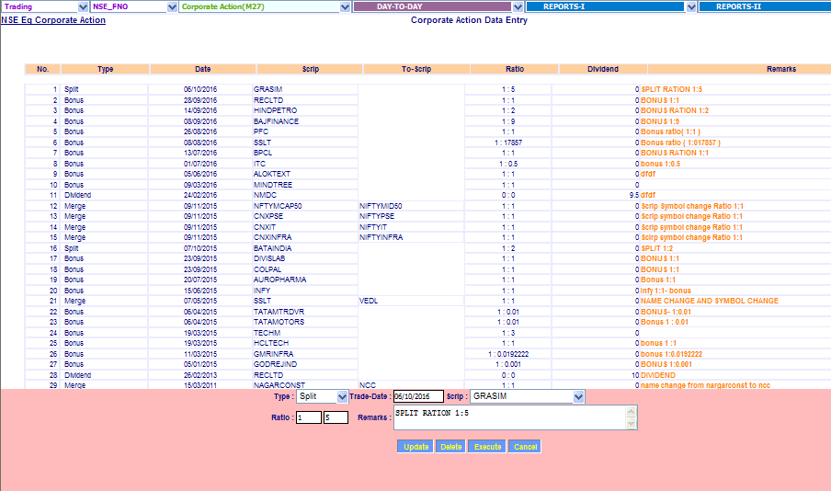

Trading- NSE_FNO-Masters-Market Lot
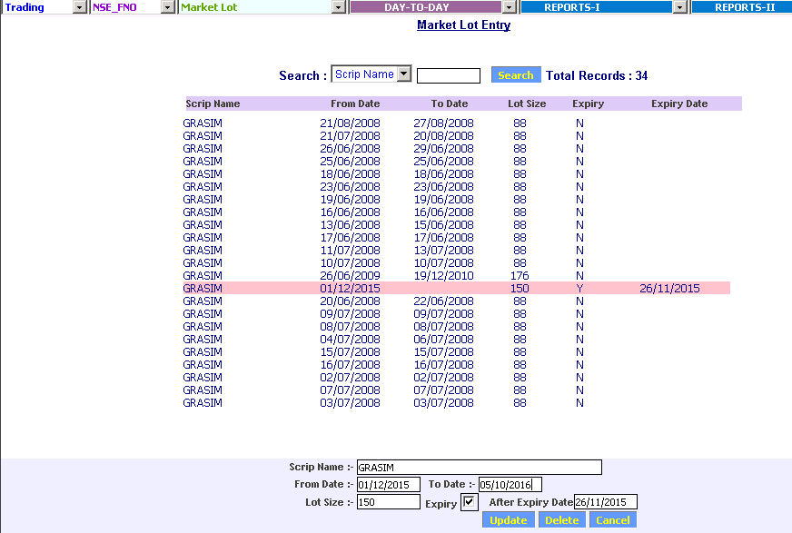

Close the existing market lot size 150 of GRASIM by inputting To date as 06/10/2016
After update will display below screen.
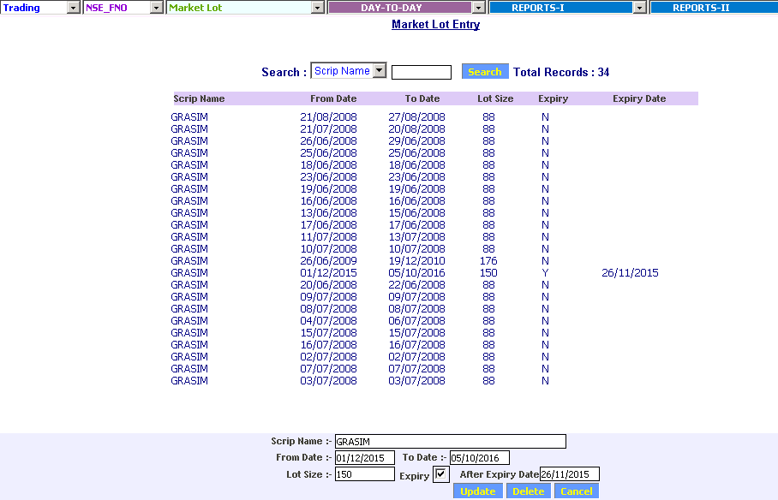
And add new entry for market lot size 750 from 06/10/2016 as shown below
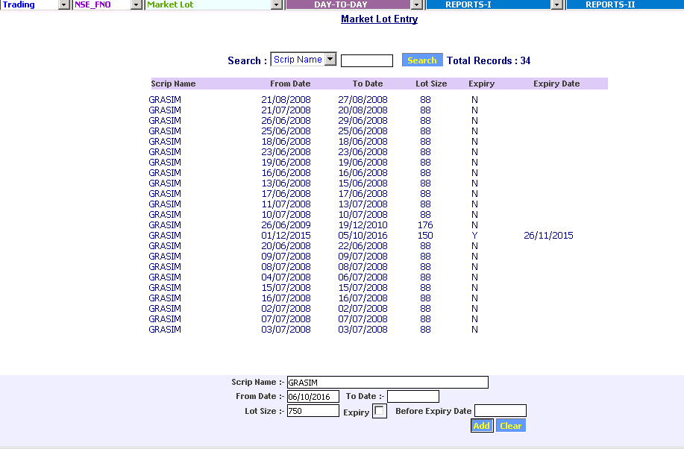

After adding the screen will appear as below
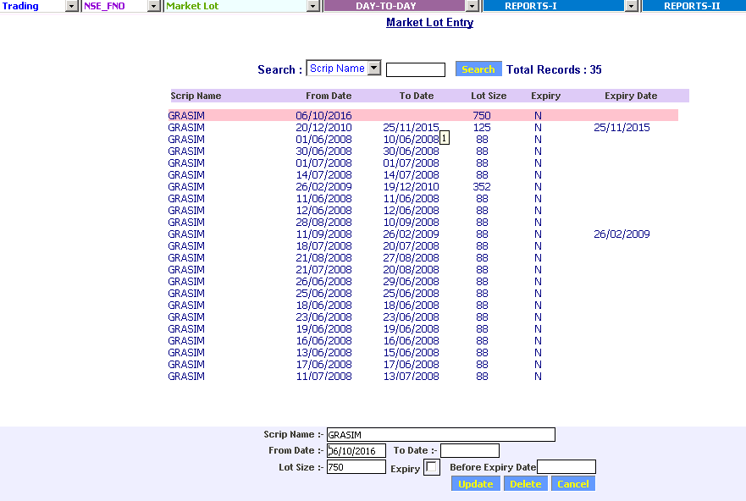

Note : After this, please cancel the bill for 05/10/2016 and do mark to market of 05/10/2016 and process the Bill for 05/10/2016 and continue with today’s work.

Note : As per the attached exchange circular if there is an option outstanding portion. Please refer the strike price table in there, strike price may differ as ratio of corporate action is odd.


